This portfolio is created by

| Name | *Saiansh Sharma* |
| --- | --- |
| Student Id | *S3993753* |
| Semester | 2023-Oct Semester |

### Declaration and Statement of Authorship

When you submit your work electronically for studio components, you must agree to the [RMIT assessment declaration](https://www.rmit.edu.au/students/my-course/assessment-results/assessment) be low.

1. I/we have not impersonated, or allowed myself to be impersonated by, any person for the purposes of this assessment.
2. This assessment is my/our original work and no part of it has been copied from any other source except where due acknowledgement is made.
3. No part of this assessment has been written for me/us by any other person except where such collaboration has been authorised by the lecturer/teacher concerned.
4. Where this work is being submitted for individual assessment, I declare that it is my original work and that no part has been contributed by, produced by or in conjunction with another student.
5. I/we give permission for my assessment response to be reproduced, communicated compared and archived for the purposes of detecting plagiarism.
6. I/we give permission for a copy of my assessment to be retained by the university for review and comparison, including review by external examiners.
7. I/we understand that:
   * Plagiarism is the presentation of the work, idea or creation of another person as though it is your own. It is a form of cheating and is a very serious academic offence that may lead to exclusion from the University. Plagiarised material can be drawn from, and presented in, written, graphic and visual form, including electronic data and oral presentations. Plagiarism occurs when the origin of the material used is not appropriately cited.
   * Plagiarism includes the act of assisting or allowing another person to plagiarise or to copy my work.

I/we agree and acknowledge that:

1. I/we have read and understood the Declaration and Statement of Authorship above.
2. If I/we do not agree to the Declaration and Statement of Authorship in this context and a signature is not included below, the assessment outcome is not valid for assessment purposes and will not be included in my final result for this course.

Visit the student essentials Academic Integrity page for more information on [academic integrity at RMIT](https://www.rmit.edu.au/students/my-course/assessment-results/academic-integrity), including your responsibilities, breaches and penalties for academic misconduct.

### Student Signature

"*I/we declare that I/we have read and understood the above Declaration and Statement of Authorship.*"

🚨 You must write your full name and student ID in the highlighted area at the top of this portfolio. **Failure to do so may result in a grade penalty or a grade of zero.**

## Instructions & Information

This notebook template has been provided to get you started on your portolfio. It's required that you use and edit the notebook correctly.

**Erase the “text answer”, “image answer”, etc. and insert your own answer.**

## Studio Class 3: Ideation & Design Principles

### Preparation Activities

**Question 1:** What problem is ideation intended to prevent?

*Ideation techniques liberate developers from current design limitations, opening up possibilities for finding new solutions to problems.*

**Question 2:** Describe each of the 5 stages of the design charrette ideation technique in 1 sentence.

| Stage Name | Description |
| --- | --- |
| *Stage 1* | *Reviewing problem statements and user research as a team.* |
| *Stage 2* | *Going through the issue statements and feedback of the users.* |
| *Stage 3* | *Evaluate and discard a few ideas* |
| *Stage 4* | *Going through the issue statements and user feedbacks again* |
| *Stage 5* | *Reviewing* *and eliminating the new designs and hence finalize the design* |

**Activity:** In preparation for the studio class, list the 10 Nielsen Design Heuristics in the table in Question 11below. You will fill in the other columns during class.

**Question 3:** Choose 2 Nielsen design heuristics. Then take screenshots of websites with a good or bad examples of your chosen Nielsen design heuristics. Include the images below each section.

**Heuristic #1: Name**

*Consistency and standards*

**Heuristic #1, Good example**

****Heuristic #1, Bad example**

*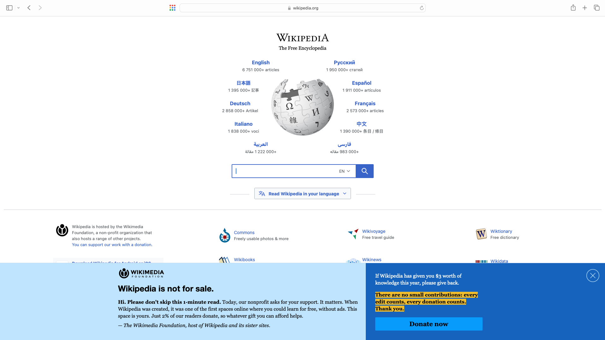***Heuristic #2: Name**

*Flexibility and efficiency of use*

**Heuristic #2, Good example**

*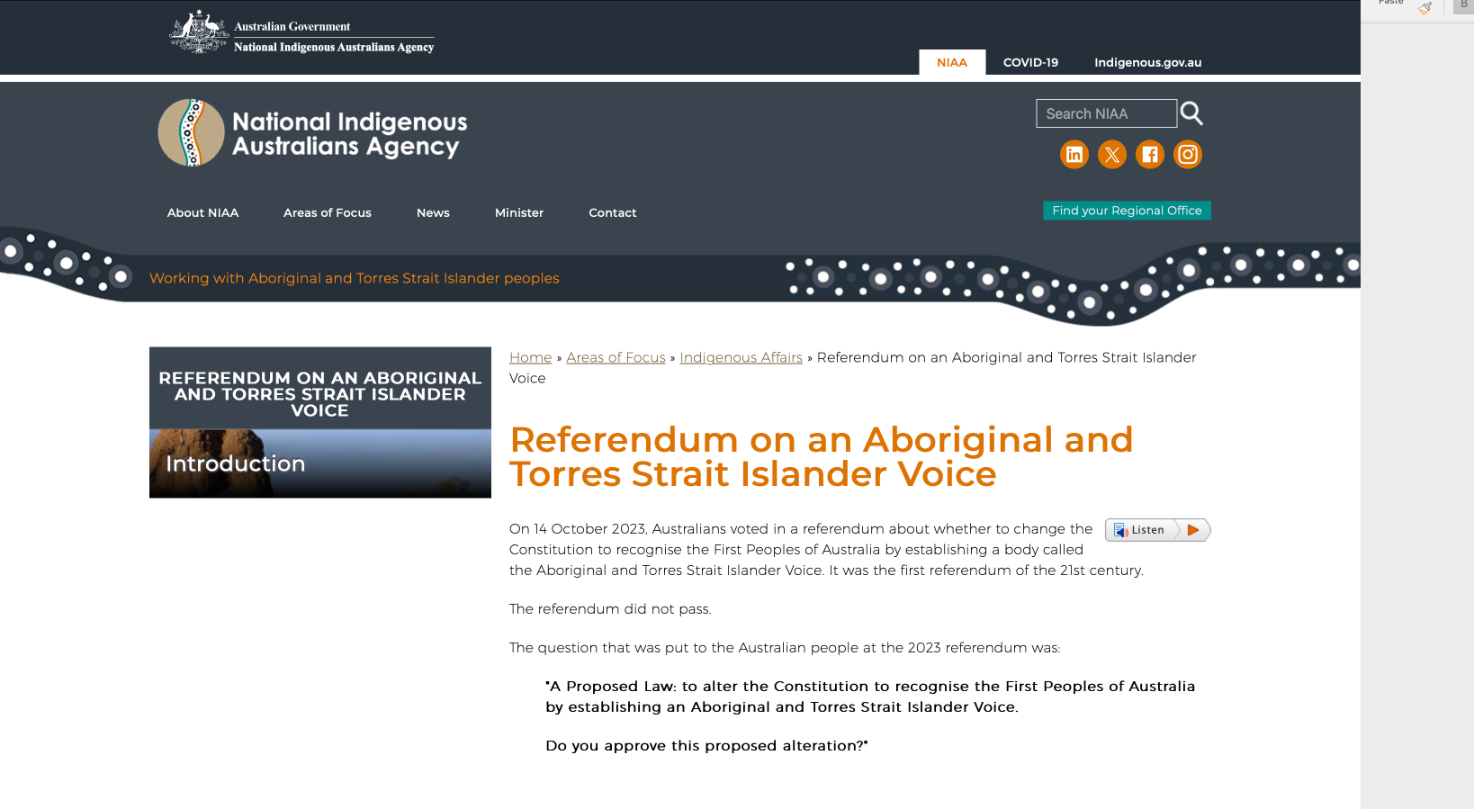***Heuristic #2, Bad example**

### 

### Studio Class Work

**Question 7a:** My Individual Trading Goods Website Personas Persona (Persona picture **ONLY**)

**

**Question 7b:** My Individual Trading Goods Website Personas Persona (Persona Text)

| Element | Contents |
| --- | --- |
| Name | *Amanda James* |
| Attributes | *A 40-year-old married woman* |
| Background | *Amanda is a doctor with a busy schedule, managing both a hospital position and her own medical practice. The daily commute between the hospital and her practice is causing her stress as she balances professional and personal responsibilities.* |
| Needs | *To alleviate stress, Amanda aims to reduce travel time by finding a residence close to the hospital and her medical practice.* |
| Goals | *Her objective is to discover an affordable and economical house that fulfills her specific requirements.* |
| Skills & Experience | *Amanda is a dentist as well as a dental surgeon, frequently performing surgeries throughout the day, leaving little time for self-care and household chores after work.* |
|  |  |

**Question 8a:** Breakout Group's Trading Goods Website Personas Persona #1 (Persona picture **ONLY**)

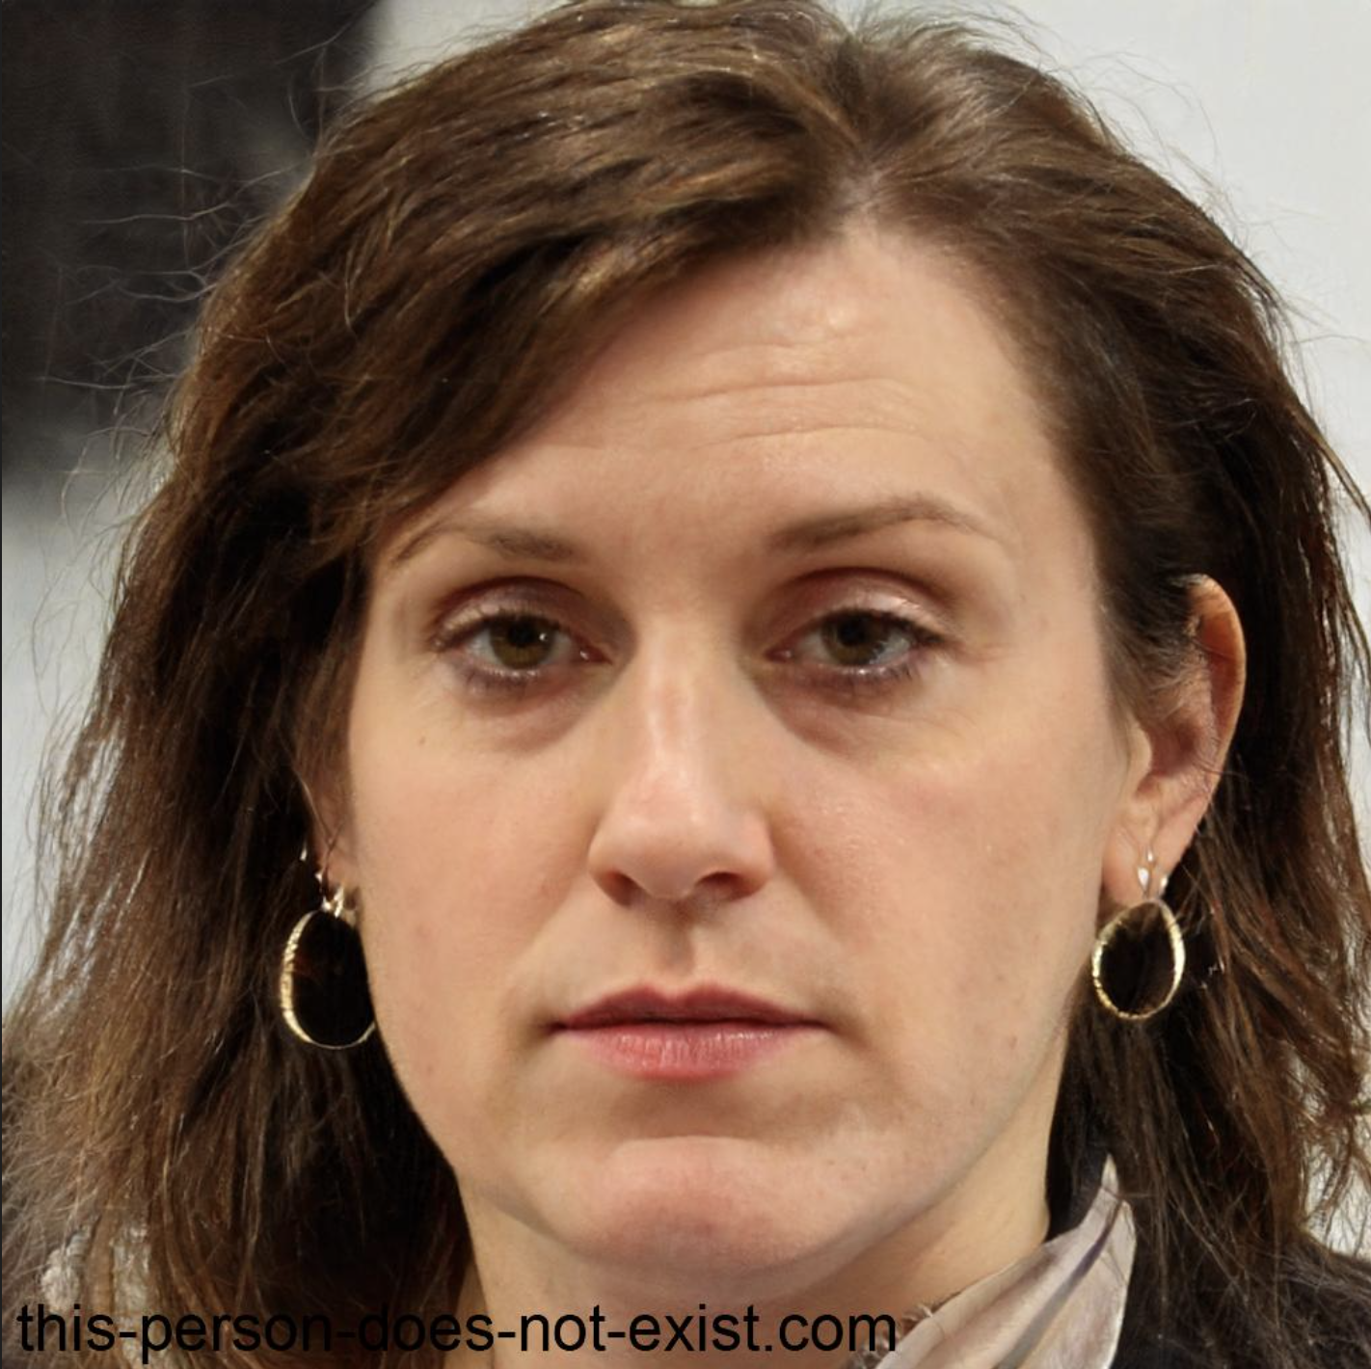

**Question 8b:** Breakout Group's Trading Goods Website Personas Persona #1 (Persona Text)

| Element | Contents |
| --- | --- |
| Name | *Alexis Stanley* |
| Attributes | *A 45-year-old married IT professional* |
| Background | *Alexis has decided to declutter her home and earn some extra income by selling lightly used possessions, aiming to maximize her Gumtree listings despite her limited experience.* |
| Needs | *She is seeking a simple and efficient listing process to swiftly showcase her items for sale.* |
| Goals | *Alexis ‘s objective is to grasp the fundamentals of online selling and enhance her skills as a seller.* |
| Skills & Experience | *Leveraging her IT background, Alexis is adept at technology, aiding her in navigating the online platform. While not an experienced seller, she is open to learning and receptive to feedback.* |

**Question 9a:** Breakout Group's Trading Goods Website Personas Persona #2 (Persona picture **ONLY**)

**

**Question 9b:** Breakout Group's Trading Goods Website Personas Persona #2 (Persona Text)

| Element | Contents |
| --- | --- |
| Name | *Lexi Brooke* |
| Attributes | *A 30-year-old accountant* |
| Background | *In addition to her role as an accountant in a bank, Lexi aspires to venture into drop shipping as a side business. She actively observes ongoing trends to identify market needs.* |
| Needs | *Lexi aims to seamlessly sell a variety of products at a rapid pace and seeks timely notifications for recommendations on what to sell.* |
| Goals | *Her ambition is to elevate her drop shipping business to a successful level quickly.* |
| Skills & Experience | *With over three years of experience in the banking sector, Lexi is accustomed to desk work, spending extended hours on the computer.* |

**Question 10a:** Breakout Group's Trading Goods Website Personas Persona #3 (Persona picture **ONLY**)

**

**Question 10b:** Breakout Group's Trading Goods Website Personas Persona #3 (Persona Text)

| Element | Contents |
| --- | --- |
| Name | *Diana Spencer* |
| Attributes | *A 32-year-old single individual, serving as the Head Chef at an Italian restaurant* |
| Background | *Recently relocated to Melbourne, facing challenges in adjusting to the new city* |
| Needs | *Seeking new apartment furniture within a $1000 budget, requiring items within a week, and facing constraints in picking up items due to a lack of private transport.* |
| Goals | *Aspiring to achieve a well-balanced lifestyle* |
| Skills & Experience | *Enthusiastic about interior design* |

**Question 11:** Nielsen Design Heuristics Complete the table below with a description and example of each Nielsen Design Heuristics

| Heuristic | Name | Description |
| --- | --- | --- |
| 1 | Visibility of system status | *Ensures users are informed about the ongoing activities within the system. Generates feedback reflecting user actions.* |
| 2 | Match between system and the real world | *Utilizes language and concepts familiar to users, presenting information consistently with their understanding* |
| 3 | User control and freedom | *Employs language and terms in line with user expectations, offering control and flexibility* |
| 4 | Consistency and standards | *Maintains uniform design elements, terminologies, and interactions throughout the system.* |
| 5 | Error prevention | *Designs user-friendly interfaces to avert mistakes; in case of errors, provides clear messages with instructions for resolution* |
| 6 | Recognition rather than recall | *Minimizes cognitive load by presenting data and choices when needed, eliminating the need for users to recall information* |
| 7 | Flexibility and efficiency of use | *Creates interfaces catering to both novice and experienced users, incorporating quick and efficient shortcuts for advanced users while remaining user-friendly for beginners* |
| 8 | Aesthetic and minimalist design | *Develops clutter-free designs focusing on essential components and content, eliminating unnecessary elements* |
| 9 | Help users recognize, diagnose, and recover from errors | *Offers clear and understandable error reports, guiding users on why an error occurred, its cause, and how to rectify it.* |
| 10 | Help and documentation | *Provides user-friendly and comprehensive assistance tools, such as FAQs, tutorials, and tooltips, to support users in accessing additional information or guidance* |

**Question 12:** Individual Ideation. (Provide your chosen persona and issue(s) in the text answers, and a screenshot of your ideation in the image answer.)

Persona:

| Element | Contents |
| --- | --- |
| Name | *Bridget Carman* |
| Attributes | *A 35-year-old married IT professional* |
| Background | *Having relocated to a new country for her career, Bridget is grappling with the challenges of balancing her professional and personal life.* |
| Needs | *She is in search of a new car to streamline her commute and desires an upgraded home office.* |
| Goals | *Bridget aims to adopt a healthier lifestyle, including incorporating home workouts into her routine.* |
| Skills & Experience | *As an IT professional, Bridget spends extended hours sitting in her office chair, facing both the challenges of prolonged work hours and occasional job-related stress.* |

Issue(s): *she finds it difficult to manage a professional and private life by facing certain issues:*

* Managing her health
* Managing time for her family and herself



